Artificial Intelligence at The Ohio State University

Ohio State has made artificial intelligence a central commitment of its institutional strategy, backed by an investment of more than $250 million across faculty, computing, data infrastructure, and academic programs. Roughly three hundred faculty across all fifteen colleges are active in AI research, and the university has committed to hiring 100 additional tenure-track AI faculty over five years.
That commitment has produced a broad portfolio: the AI^{(X)} Hub; the university-wide AI Fluency initiative; operational AI services through the Office of Technology and Digital Innovation (OTDI); the Translational Data Analytics Institute (TDAI); two NSF AI Institutes (AI-EDGE and ICICLE); one NSF HDR Institute (Imageomics); the first NSF center dedicated to responsible AI governance (CRAIG); and college-based domain centers including the Arts and Humanities AI Institute (AHAII), Buckeye BioLaunch for AI-enabled therapeutics, and the BuckAI Observatory for applied AI in the natural and mathematical sciences.
These assets are organized under an overall One University AI Strategy with three distinct arms: the AI^{(X)} Hub as the research, graduate education, and research computing arm; the AI Fluency initiative in Academic Affairs for undergraduate AI education and student entrepreneurship; and the Office of Technology and Digital Innovation (OTDI) for production AI services and enterprise infrastructure. College-based domain centers form the application layer through which all three are translated into field-specific impact. This Center draws principally on the first arm, the AI^{(X)} Hub.
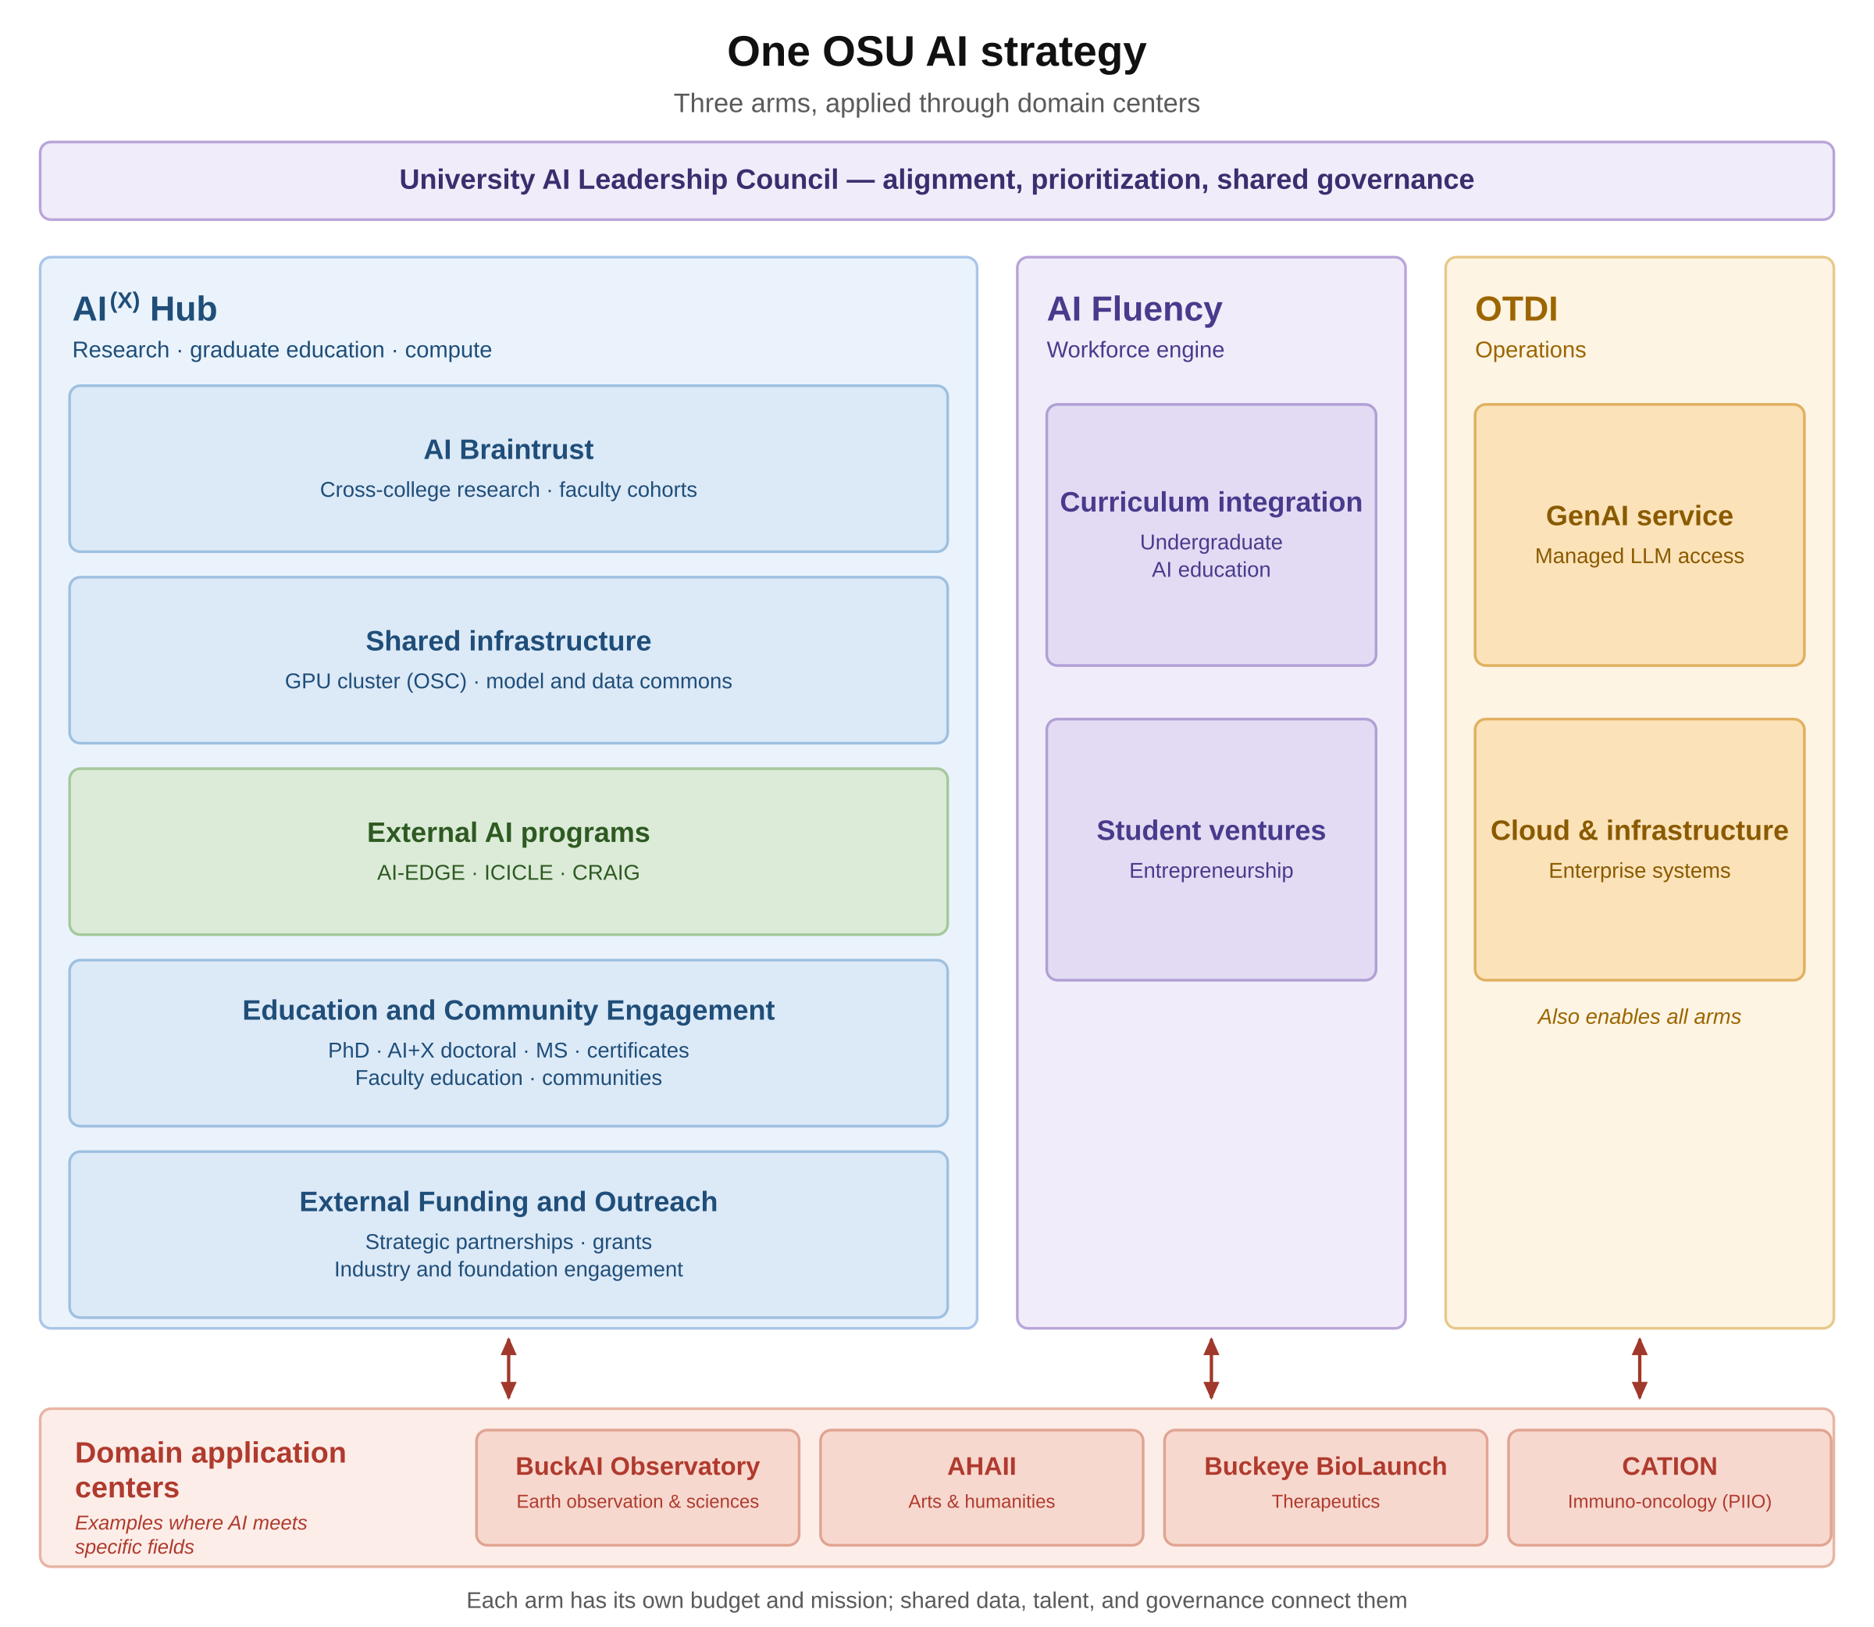
The AI^{(X)} Hub
The AI^{(X)} Hub is the research arm of Ohio State's university-wide AI initiative and the coordinating authority for AI research, graduate AI education, and research computing. It reports through the Enterprise for Research, Innovation and Knowledge (ERIK) and spans fifteen colleges and the Wexner Medical Center. Its function is to bring AI scientists and domain experts together around problems no single unit can solve alone, backed by shared computing and data infrastructure that no single college could fund. The Hub is organized around six strategic pillars, which structure its faculty Working Groups, three faculty hiring cohorts, and research portfolio.
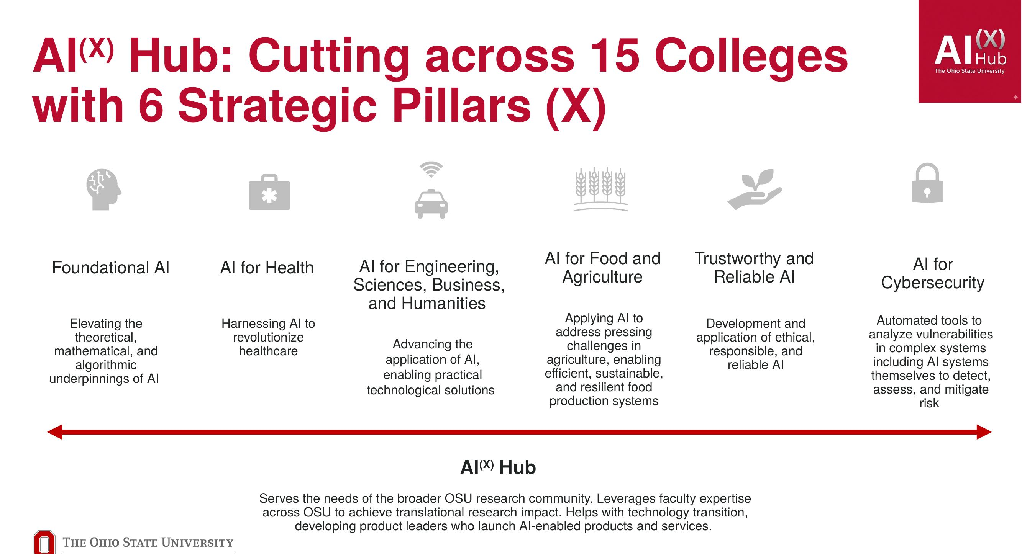
Figure 1. The AI(X) Hub spans fifteen colleges through six strategic pillars.
The Hub is directed by Ness Shroff, Ohio Eminent Scholar and director of the NSF AI-EDGE Institute. Governance operates through pillar-aligned Working Groups; an Internal Advisory Committee drawing on ERIK leadership and college, institute, and central research administration representation; an Executive Oversight Committee of senior university leadership including the Provost's Office and deans of research; and an External Advisory Board of academic, industry, and national-laboratory leaders.
Research Computing Infrastructure: A partnership between AI^{(X)} Hub and OSC
Ohio State's AI computing is delivered in partnership with the Ohio Supercomputer Center (OSC), a member of the Ohio Technology Consortium within the Ohio Department of Higher Education. OSC systems are housed in the State of Ohio Computing Center, a secure, state-subsidized facility, with dual-site replicated storage across Columbus and Cleveland. OSC operates a Protected Data Service and supports HIPAA-regulated and export-controlled research, which is the mechanism by which sequestered clinical benchmark data can be held and evaluated under state and university governance rather than in commercial cloud. OSC also provides research software engineering support and a dedicated AI and machine learning service line.
OSC's production systems deliver a peak performance of 30.3 petaflops with approximately 26 petabytes of disk storage, and currently operate 1,068 NVIDIA GPUs across three clusters: 128 H100 with NVLink on Cardinal, 776 A100 on Ascend, and 164 V100 on Pitzer.
The AI^{(X)} Hub and OSC have committed to a five-year plan for dedicated AI computing, covering hardware, power, operations, and personnel across the full lifecycle. Year 1 expands Cardinal with a dedicated Hub system of 128 NVIDIA B300 GPUs across sixteen liquid-cooled Dell PowerEdge XE9780L nodes, procured under State of Ohio contract and expected in production at OSC by June 2027, one month before the earliest PRIMED-AI award start. Later years fund a next-generation system that combines OSC capital with Hub funds, together with storage expansion that will grow this system by a factor of 4. The plan funds eight dedicated technical staff for user onboarding, systems and application engineering, and project management, and sustains a fifth year of full operations from an internal reserve accumulated across Years 1 through 4, with published lifecycle projections extending to Year 8.
Alongside the OSC system, the Hub operates a separately funded experimental GPU cluster, in use today, providing an insulated environment for high-risk evaluation work that must not disturb production systems. This experimental cluster currently consists of 8 NVIDIA B200 GPU, with an expected expansion to 24 NVIDIA B200 GPUs by June 2027.
Frontier and Open Access Models
Since August 2025, Ohio State has held an enterprise agreement with Google providing secure access to Gemini, NotebookLM, Google Workspace applications, and Google CoLaboratory™under institutional terms. There are efforts underway to extend this agreement to research use, including Co-Scientist and Gemini Enterprise.
Two further efforts can be used for validation efforts. The AI^{(X)} Hub is working to pool resources across colleges to procure frontier models from other providers, including Anthropic and OpenAI, at negotiated rates under agreements that keep university data governed by institutional terms. In parallel, the Hub and OSC are building a supported path for running current open-weight models on university computing, so a model can be evaluated on premises without sending data to a commercial API. Together these give the Center access to both closed frontier models and open-weight models under a single governance regime.

Model and Data Commons
Ohio State holds world-class computing through OSC, strong data repositories through University Libraries, and deep domain expertise across colleges. The Model and Data Commons is the layer that connects them. It is being designed to include discoverable datasets, reusable models, shared engineering workflows, and institutional memory. The Hub designed its architecture and has convened faculty, OTDI and Wexner Medical Center engineers, and OSC staff to define resource needs and prevent siloed development.
Architecture. The Commons is organized around four risk-based access zones with a defined promotion path, so a dataset or model moves between zones under stated criteria rather than by negotiation. A shared metadata and lineage plane spans both halves, binding each model to its training data, evaluation set, and performance history. This binding matters for validation: a model without its data provenance and drift history is not independently reproducible, and a validation finding that cannot name the exact benchmark version it was measured against is not defensible. The Hub is aligning the zone design to the Five Safes framework and the published SATRE specification for trusted research environments, and the access model to the tiered-access and data-perimeter patterns of the All of Us Researcher Workbench.
Model egress as an open problem. Trusted research environments have largely solved controlled data egress; releasing a trained model from a restricted environment without leaking what it memorized remains unsolved, and tooling for it is thin. That sits precisely at the seam this Center operates in: the Validation Core receives models trained elsewhere, evaluates them against sequestered data, and must release findings without compromising the holdout. This is a research priority for the AI^{(X)} Hub and a place the Center can contribute and adopt.
Faculty, Staff, and Academic Programs
Embedded technical staff. The Hub maintains standing engineering and research capacity that includes 1 ML software engineers, 2 research scientists, and 2 postdoctoral researchers that are assigned directly to supported projects for code development, data engineering, and model development.
Faculty hiring. As mentioned earlier, the university has committed to one hundred tenure-track AI faculty over five years. These are being hired across the following cohorts: 60 in Applied AI (30 of which will be in AI for Health); 30 in Foundational AI; and 10 in Responsible AI and Cybersecurity. The Hub’s Working Groups authored the evaluation rubrics used across the initiative and the AI faculty being hired through this initiative will be integrated to the AI^{(X)} Hub braintrust and interact with domain experts to accelerate research, drive innovations, and conduct validation.
Graduate and undergraduate programs. The Hub has designed an interdisciplinary AI+X doctoral program training scholars simultaneously expert in AI methods and fluent in a disciplinary domain, with first enrollment targeted for 2028. The university's AI Fluency Initiative, in Academic Affairs, is building AI competency into undergraduate education beginning with the Class of 2029.
Federally Funded AI Centers and Institutes
NSF AI-EDGE Institute. A $20M+, five-year NSF AI Institute co-funded with the Department of Homeland Security and led by Ness Shroff at Ohio State, advancing AI for future edge networks and distributed intelligence. AI-EDGE has a substantial open-source and dataset release record, has launched five startups, and has received significant additional funding and technical expertise from 14 companies, and DoD labs (ARL, AFRL, and NRL) in its research thrusts.
NSF ICICLE Institute. A $20M, five-year NSF AI Institute led by D. K. Panda at Ohio State, with 46 researchers across 13 organizations, building next-generation cyberinfrastructure for a trustworthy national AI infrastructure. Its work on reusable engineering workflows is the direct technical antecedent of the Hub's Model and Data Commons.
NSF Imageomics Institute. A $15M NSF institute for data-intensive discovery led from the Translational Data Analytics Institute, with Tanya Berger-Wolf as director. Its methodological core is directly relevant to medical imaging: the institute has produced widely used vision foundation models and image-based benchmark datasets.
NSF CRAIG. The Center on Responsible AI and Governance is the first NSF Industry–University Cooperative Research Center dedicated specifically to responsible AI. Led by Dennis Hirsch and housed at the Moritz College of Law, with Ohio State as lead site and partners at Baylor, Northeastern, and Rutgers, CRAIG focuses on safe, accurate, impartial, and accountable AI. CRAIG gives this Center direct access to faculty who work full-time on AI auditing and model transparency, and to an established industry-facing governance structure.
Domain Application Centers
College-based domain centers apply AI within a specific field while drawing on Hub research, infrastructure, and data. The Buckeye BioLaunch applies AI to therapeutic discovery and development across the Wexner Medical Center, the OSUCCC–James, and the Colleges of Medicine and Pharmacy. The Center for AI & Bioinformatics in Immuno-Oncology (CATION) serves as the computational and analytical engine and one of the insight-discovery platforms of the PIIO, dedicated to advancing cancer immunotherapy through high-quality data analysis, bioinformatic tool development, statistical consulting, and interdisciplinary training. Others include the Arts and Humanities AI Institute and the BuckAI Observatory in Arts and Sciences. These centers return real-world problems to the Hub, which is the mechanism by which clinical requirements shape research priorities rather than the reverse.
Translational Data Analytics Institute
TDAI, launched in 2015, brings 250+ affiliated faculty from fifteen colleges and more than sixty disciplines into five Communities of Practice, including one on Responsible Data Science. It operates a 19,000 square foot facility in Pomerene Hall between the academic core and the Wexner Medical Center, and provides shared data science services and federated access to high performance and cloud computing with FAIR-compliant workflows. Tanya Berger-Wolf is faculty director. TDAI intersects closely with the AI^{(X)} Hub as a cross-cutting institute serving all six pillars.
Convening, Peer Review, and Subaward Capacity
The Fast Track Core depends on three institutional capabilities beyond research expertise: convening a consortium to surface and prioritize gaps, running a credible NIH-style peer review, and administering subawards to institutions outside the applicant organization. Ohio State has a demonstrated record in each.
Convening and gap identification. The Hub's Annual Grand Challenge Workshop is the process the Fast Track Core proposes, at university scale: a structured ideation format that moved cross-college participants from open problem statements to seven prioritized coalitions with named leads, staged milestones, and technical charters. Six further university-wide convenings addressed data governance, cross-college connection, and coalition formation.
Peer review and competitive selection. The Hub allocates technical staff and seed funding through published rubrics and tiered selection criteria, so internal competitions are decided on stated criteria with decisions recorded. The ERIK Research Development Office institutionalizes Pink and Red team review for large federal submissions. The Clinical and Translational Science Institute, directed by Julie Johnson, one of this Center's MPIs, operates established pilot-award machinery covering solicitation, review, and post-award tracking; CTSI resources are described in the accompanying institutional resources document.

